HAWKER COLLEGE MI Group NEWS
Semester 1 – Week 8 Monday 23rd March 2015

Are You into Books-Library

 | 

Are you into books?
Do you love to read, discuss and hang out with other people who share your passion?
Anyone who loves to read is invited to come to the Library on Wednesday 25th March at 1pm to talk about books and maybe starting a book group at Hawker College. Come by yourself or bring a friend. We will supply the books!
Jane and Linda
 | 

Golf
Do you need points for year 12 Certificate?
Come hit some balls at the driving range?
Have a game of pitch and putt?
Play mini golf.
Thursday afternoons 2: 15pm to 4 pm
At Canberra International Golf Centre in Narrabundah
Costs Pitch and Putt 18 holes $8.50 9 holes $6.00
Driving range: 50 balls $8 75 balls $10 100 balls $12 Mini Golf $6
See Mark D’Arcy in Room 84 for a note.

National Youth Week Celebrations at Hawker College
In Week 10 (Tuesday 7/4/15 - Friday 10/4/15) the DEN Team, in conjunction with staff and students across the school will be running a celebratory, educational event to mark National Youth Week 2015. The event will be coordinated around the theme of "Healthy Mind, Healthy Body, Healthy Community".
During this week the following extra-curricular activities will take place in the college community.
Tuesday 7/4/15: BATYR Youth Mental Health presentations
- Yr 11 Line 2 session 1 (9:45-10:45) and Yr 12 Line 1 session 2 (12:00 -1:00) in the HWKC Theatre. All students in the scheduled Year group are expected to attend instead of normal scheduled classes.

Wednesday 8/4/15 - External Service EXPO
- Line 5 (12:00-1:00), Lunch and Line 6 (1:45-2:45). This is a voluntary activity for interested students to attend on free lines or at lunchtime. Healthy Snacks will also be provided at lunchtime .

Thursday 9/4/15: Lifeline Peer Skills Workshop
Lunchtime and Line 8 (1:00-4:00pm). Interested students to attend on first come first served basis - max 50 students. This activity will be fully funded by a NYW grant. Students to sign up on the list outside Antonella’s office if they would like to attend.
Friday 10/4/15 - 'Flanny Friday' Theme day / Lunchtime Celebration
- Dress up in your Flannel shirt (or similar item) to support mental health and wellbeing at HWKC.
- There will also be a Poetry Slam and/ or musical performances in HWKC theatre at lunchtime

Looking forward to enthusiastic participation in what should be a great week.

She Leads Conference

The "She Leads Conference", an excursion opportunity, is currently available for female students at HWKC who are interested in developing their leadership skills...
The day will feature a full program of speakers, workshops and individual and group discussion and reflection. Students who attend will also be asked to commit to taking some action following the conference – for example writing a post for publication on the YWCA Canberra ...
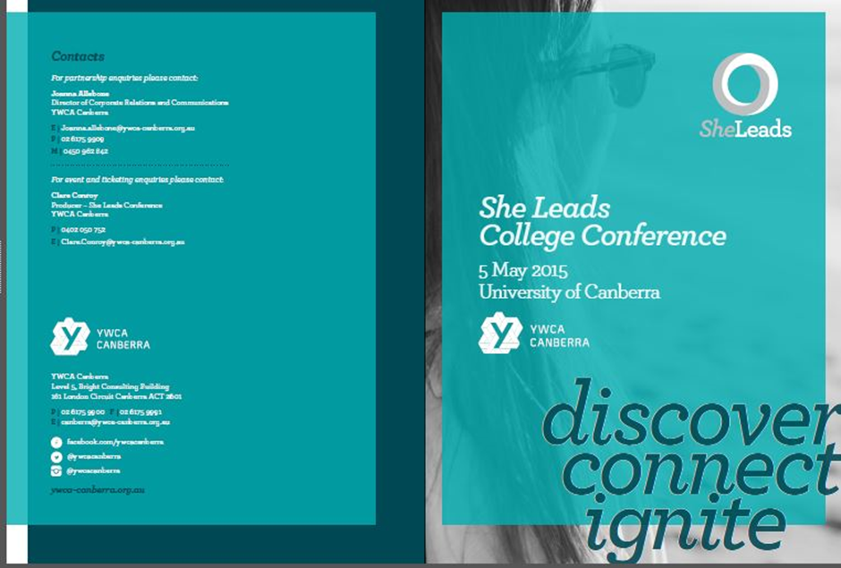

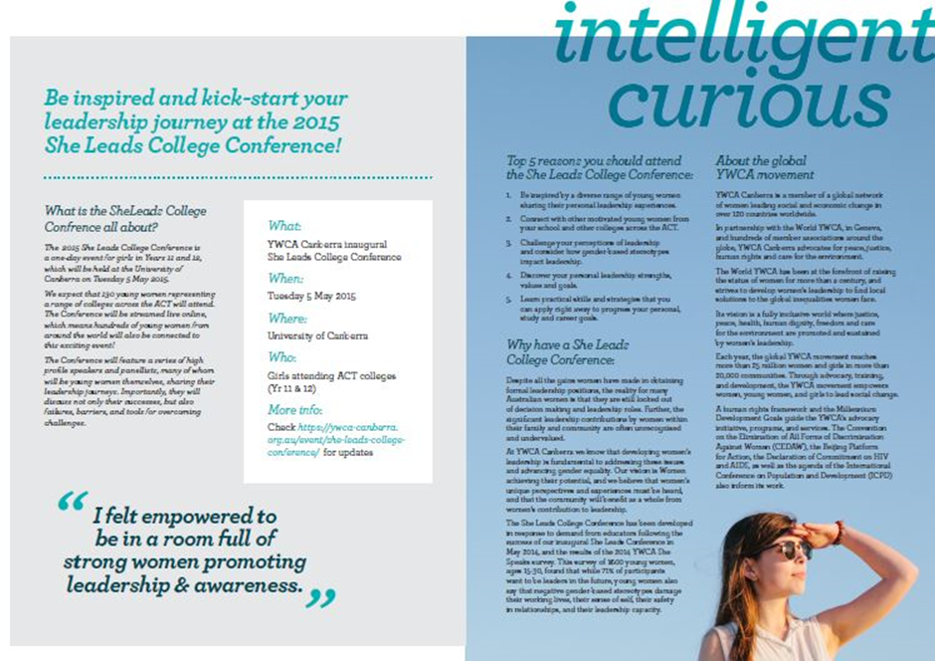


 | 

SHLiRP
Sexual Health, Lifestyles & Referral Program

Coming to Hawker College on Monday 30th and Tuesday 31st March, 2015

What is SHLiRP?
SHLiRP is a simple and convenient health education, information and testing program to promote young people’s sexual health and wellbeing. The Program is a partnership of Sexual Health and Family Planning ACT (SHFPACT) and the Canberra Sexual Health Centre (CSHC) brought to ACT public secondary colleges with the support of ACT Government funding.

SHliRP has been successfully delivering health education and an opportunity for on-site sexual health screening in ACT secondary colleges for 10 years, with the support of students, parents/carers and teaching staff.
SHLiRP Program at HWKC
Year meetings | 16/3/2015 11.15am Yr 11  23/3/2015 12.00 am Yr 12 | Murranji Theatre: Yr 11 and Yr 12 will receive introductory information re the SHLiRP program in 10 minute sessions as part of scheduled Yr Meeting Agenda
SHLiRP Sexual Health Presentations | Monday 30/3/2015,  Girls session – 8:45 – 9:30am (line 7)  Boys Session – 9:30- 10:15am (Line 6) | Murranji Theatre: ALL HWKC Girls in Line 7 and Boys in Line 6 will attend educational presentations re Sexual Health in 45 minute sessions instead of normal class activities. Normal classes will run for students of the opposite gender
SHLIRP Clinic Days | Monday 30/3/2015,  Tuesday 31/3/2015 | DEN: Students will book into clinic sessions voluntarily for check-ups and testing – preferably on free lines depending on nurse availability
Results day | Tuesday 28/4/2015 | DEN: Students who attended clinic sessions for testing will receive results as scheduled by Nurses

