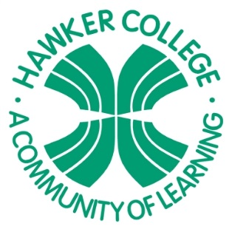 | Hawker College Strategic Plan 2016-2020  Belconnen Network

Strategic Priority 1: Articulate the college vision, mission and message and promote internally and externally to build school culture and establish a strong and visible presence in the local community

Outcomes to be achieved:
Targets
By the end of 2020 the school /college will achieve:
- An articulated vision, mission and message understood internally and in the community as evidenced by system survey results
- Increased student identification with and connection to the college as evidenced by system survey results
- Increased community awareness of and engagement with our college as evidenced by increased attendance rates at parent/ teacher evenings as a proportion of cohort
- A greater proportion of student enrolments from the priority enrolment area (PEA), compared with total eligible numbers in the PEA, at Hawker College.
Key Improvement Strategies | Key Performance Indicators
Hawker College Vision, Purpose, Values and Graduate Profile documents revised and communicated widely to community | - 75% of stakeholders indicate awareness of college vision and mission
Develop and implement a clear marketing strategy | - A greater proportion of PEA student enrolments at Hawker College.
Continue to foster transition and enrolment programs connecting with network schools | - Increasing proportion of prospective students engaging with transition opportunities
Continue to foster student connection, identification, leadership and empowerment opportunities at Hawker College | - Increase in student identification and satisfaction with the college as evidenced by Student Satisfaction Surveys

Strategic Priority 2: Develop a systematic approach in collecting, analysing and using a range of formative student data that will provide a greater support for student learning and visibility of student progress within courses.

Outcomes to be achieved:
Targets
By the end of 2020 the school /college will achieve:
- Increasing proportion of cohort with student profile documentation as the source of baseline data for student growth
- Evidence of full teacher engagement with formative assessment processes
- Improved student outcomes measured by Grade Point Average (GPA)
Key Improvement Strategies | Key Performance Indicators
Each class/unit in the college will have a presence on Google Classrooms | - Each class/unit in the college has a functional presence on Google Classrooms  - Evidence of formative assessment tasks delivered via Google Classrooms
Regular teacher meetings occur to analyse and use a range of formative student data. | - Evidence of the use of a range of formative student data through Professional Pathways and PLC documentation
Staff access Student Profile data to inform planning and intervention processes | - Evidence within Professional Pathways of use of student profile as baseline data to inform planning

Strategic Priority 3: Create a process to develop and share highly effective and evidence-based teaching and learning processes.

Outcomes to be achieved:

Targets
By the end of 2020 the school /college will:
- Strengthen teacher collaboration, mentoring and professional learning and promote sharing of effective and evidence based teaching and learning processes
- Consolidate the place of authentic learning and student enterprise in college programs
- Increase use of digital pedagogy as an effective support for student learning

Key Improvement Strategies | Key Performance Indicators
Embed Collaborative Classrooms process and professional learning through PLCs at Hawker College | - Extent of useful feedback reported in system surveys by teachers  - Effect size (value-add) data eg ATAR results compared with past NAPLAN for each cohort  - Year 12 completions
Embed authentic learning and promote student enterprise in college programs | - Student survey data on related questions such as motivation and interest in college programs
Provide professional learning on current opportunities to use digital pedagogy effectively and build this into policies and procedures | - Extent of uptake in digital pedagogy and related student survey responses such as “My school looks for ways to improve”

