Hawker College Library

A guide to accessing Oliver and Databases

Oliver is the Hawker College Library Catalogue. It allows you to search resources available at Hawker College Library and tells you where to find them in the collection.

To access:
Log on to Backpack and click on the Oliver icon
This will take you to the Oliver home page. From here you can search Hawker College Library catalogue. Using the search box search by Author, Subject, Title. It is limited so keep your search terms broad.
From the Oliver Home page you can also access links to various FREE research resources.
- Libraries ACT
- National Library of Australia
- Tips on research skills
- And reference generators.
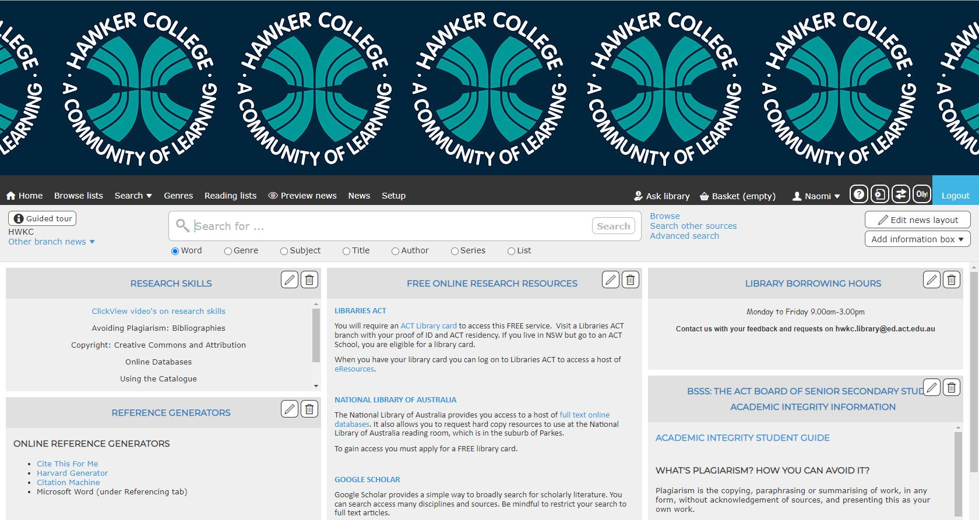

Accessing Libraries ACT
Once you’ve accessed Oliver Home Page select eResources located under
- Free Online Research Resources
- Libraries ACT
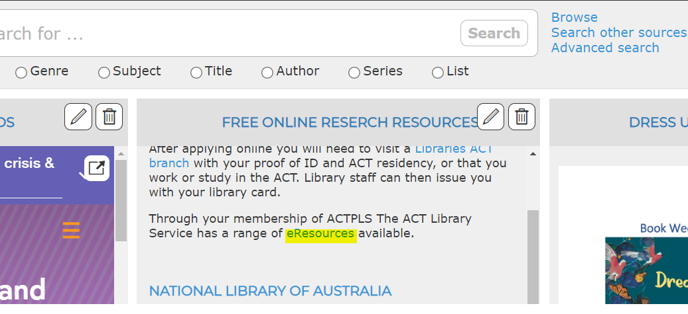
This will take you to Libraries ACT website. From here you can:
- Register to become a Libraries ACT member (note that you will still need to visit a Libraries ACT Library to finalise your membership and collect your Libraries ACT card.
- Once you are a Libraries ACT member from this page you can access Digital Resources by selecting Digital Resources on this page.
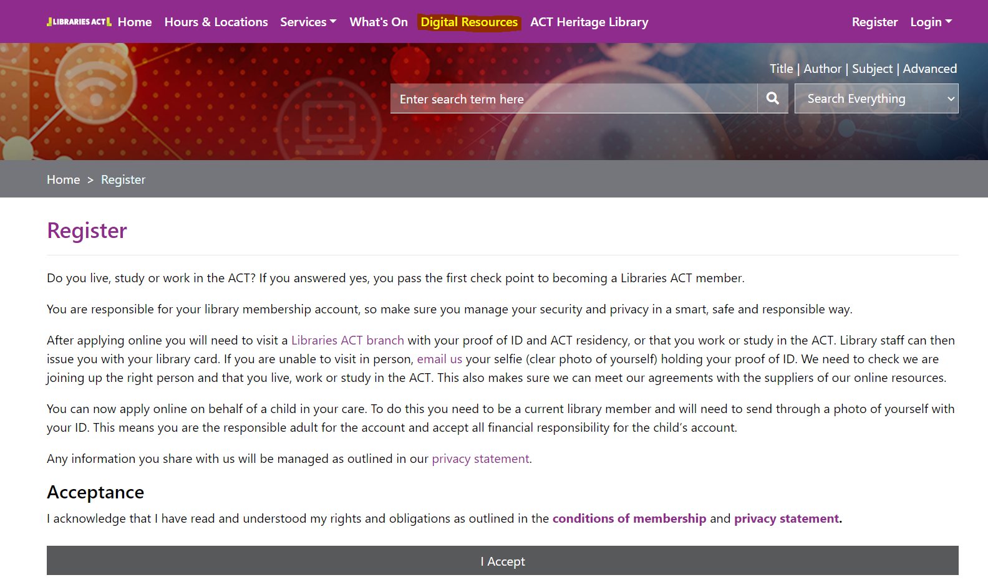

Once you are a Libraries ACT member login with your username and passphrase to access eResources
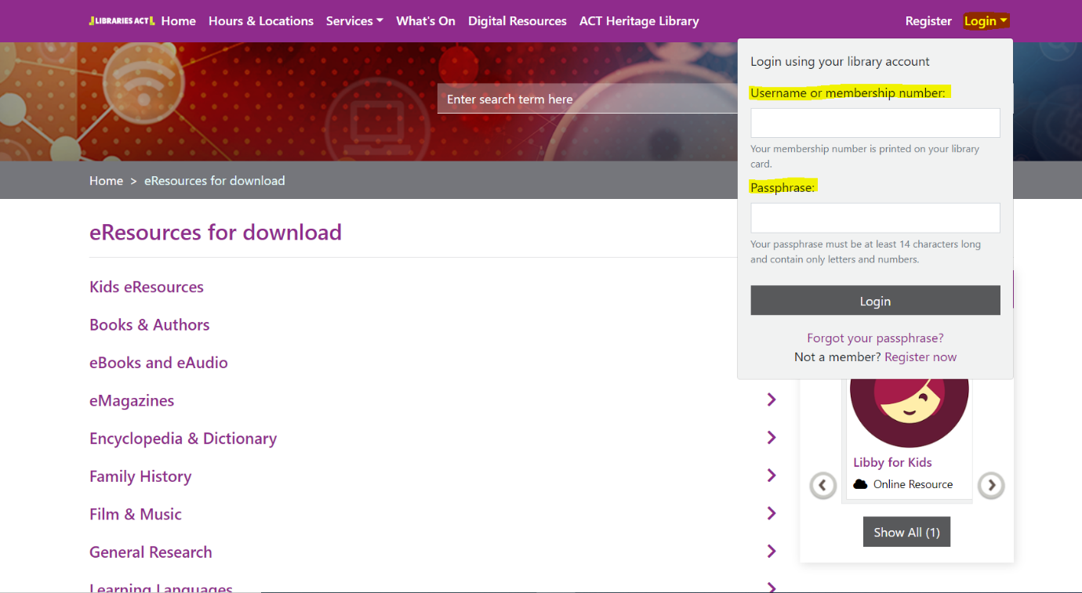
Congratulations, you now have free access to endless useful online databases!
From here select
- General Research
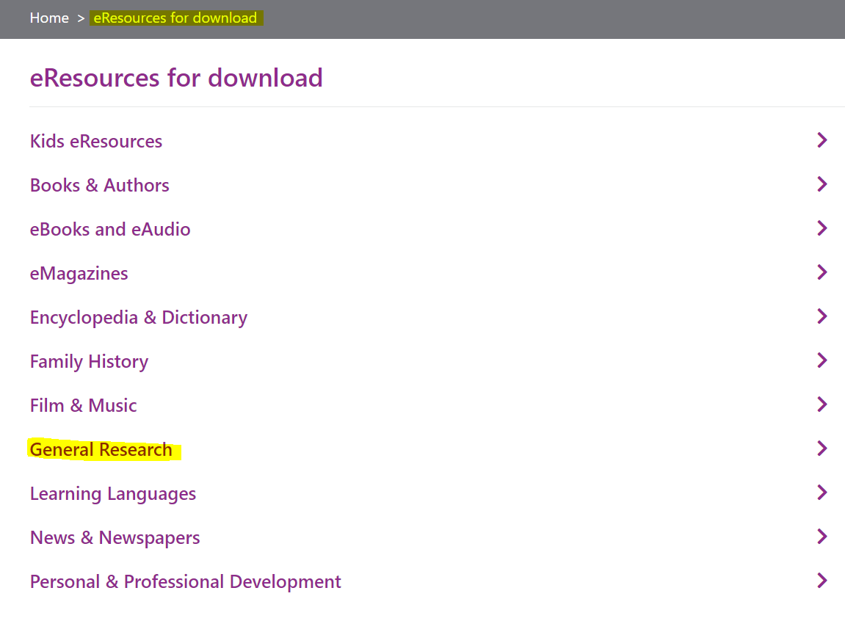
Scroll through until you find
- Gale General OneFile
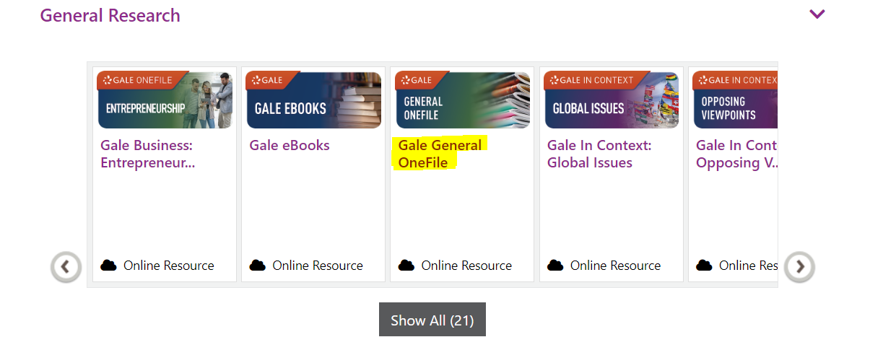
Select
- Access resource
