Hawker College Library

A guide to searching Gale OneFile
Gale OneFile is accessed through Libraries ACT. See Hawker College Library: A guide to accessing Oliver and Databases for instructions on how to do this.
Once you’ve logged onto Gale General Onefile there are many search options. I suggest using the Advanced Search option as you can make your search specific to your needs.
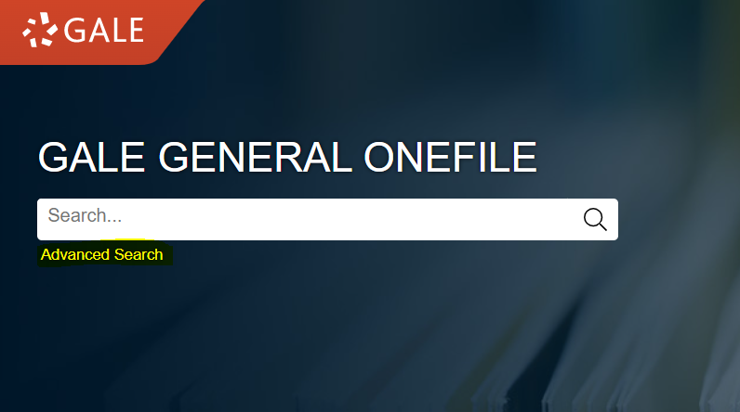
Type in your search term/s and select Documents with Full Text and if required Peer-Reviewed Journals. You can also narrow your search to document type, publication title and a date or date range.
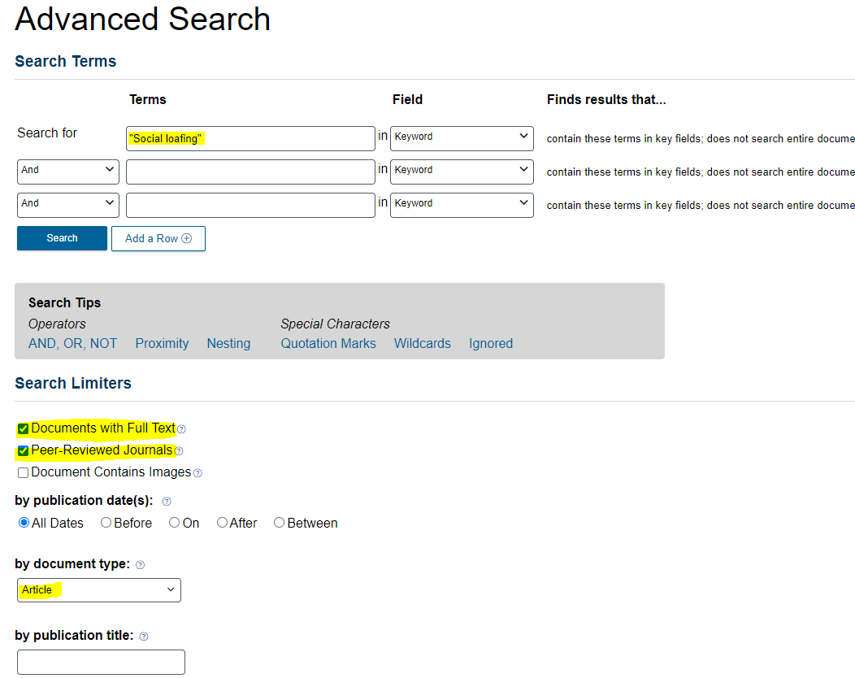
In this search example titles with only Full Text, Peer Reviewed and document type, Articles, will be shown.

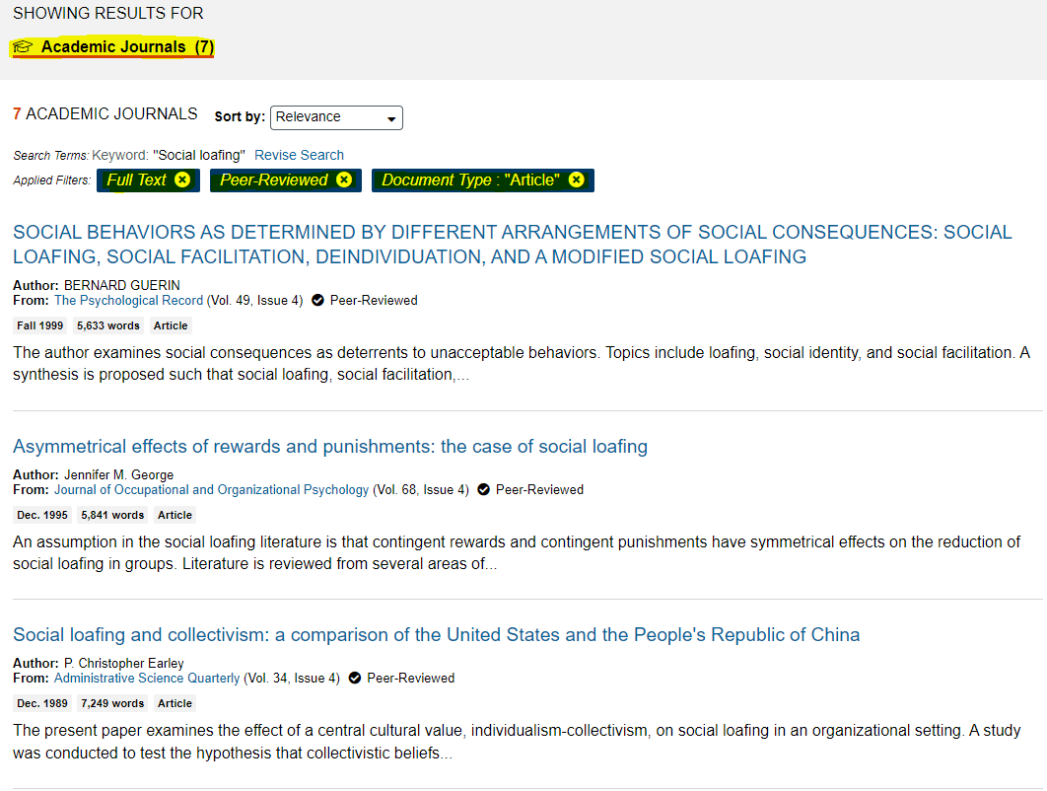
Review the articles and decide if any of them are appropriate to your needs. If so, you can email the full text article to yourself, download or print it.
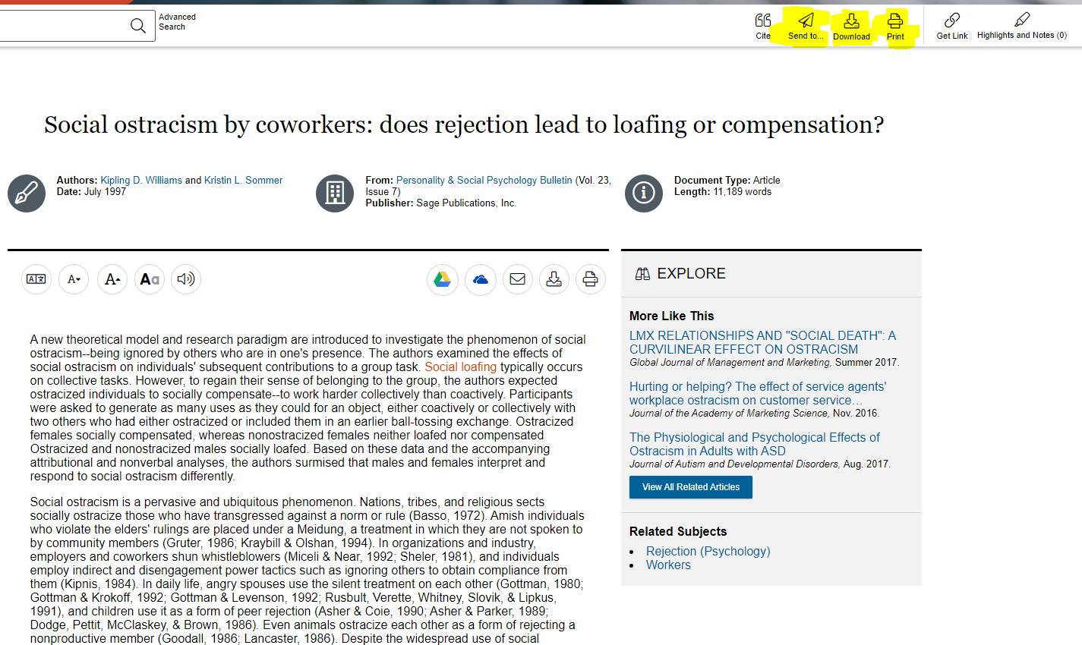
You are also able to download the citation for the article for your Bibliography.
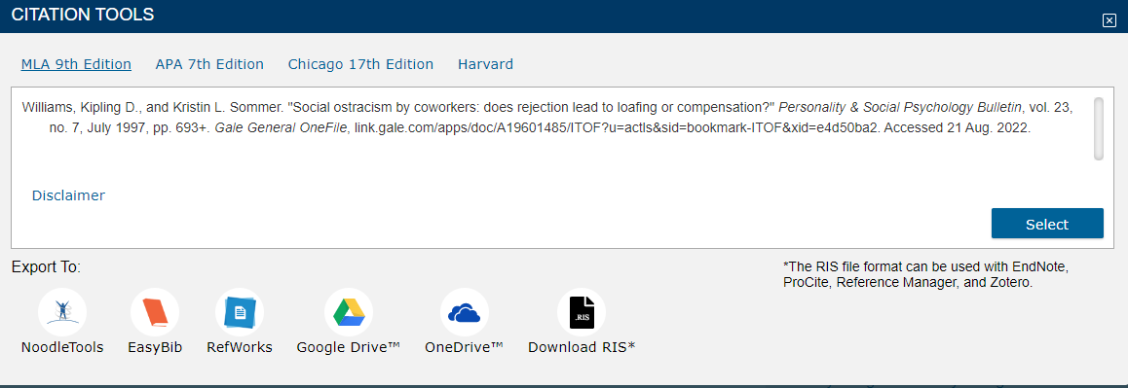

Topic Finder
From here you can also narrow your search criteria by using Topic Finder.
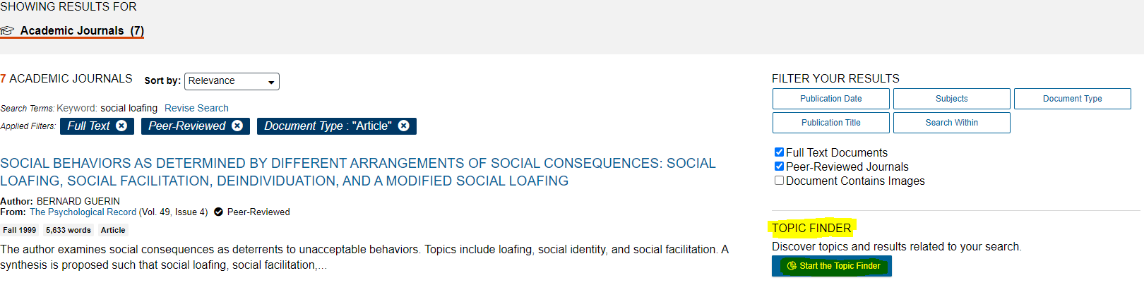
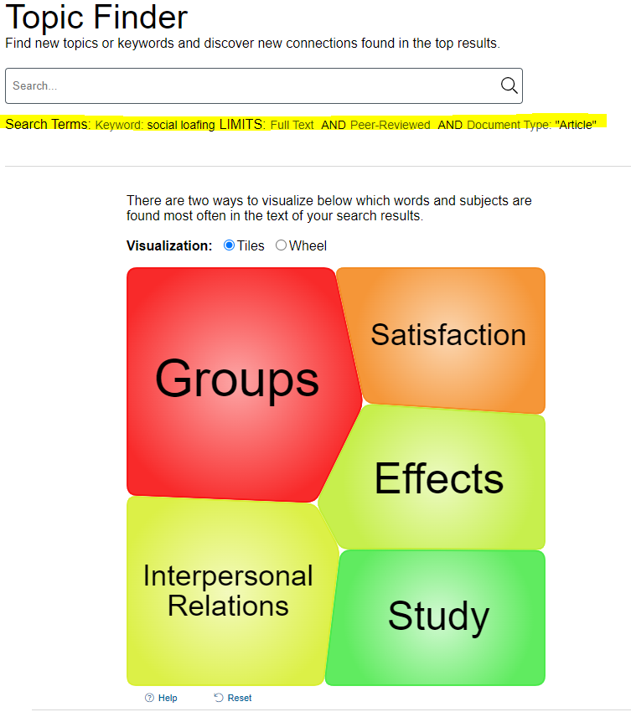
Click on a section to display results. In this example we will select Groups. The results will now narrow your original search to include Groups. This has brought the original search down from seven full text articles to three relevant full text articles.
