Instructions - Student Class Selection - 2015

Access to the list of classes to be offered in Semester 1 2015.
This list is linked to the college website.
Classes are listed by line as well as by course. Make sure you record the correct class number and gridline.

- The first thing you should do is to choose what classes you want to take on which lines.
Even if you don’t want to make any changes to your courses you will still need to select those classes in the class selection program.
If you do wish to make changes to your package you should discuss them with your MI Group teacher or someone from Careers or the Den.

2. Then, you will need access to a computer with internet access. The web address of the subject selection program (Prophet) is http://prophetapp.com.au/hawker There is also a link from the college website.

3. When you reach the Home screen save the site to your favourites for an easy return later.

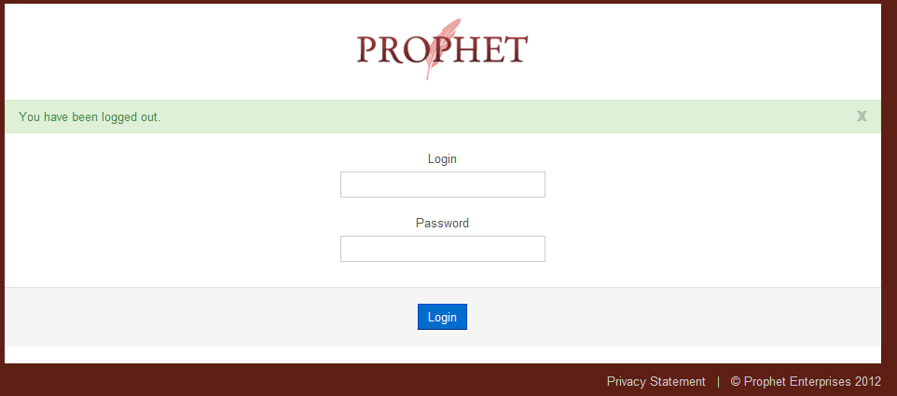

You MUST use your own student ID and Date of Birth for this login

Username Your username is your StudentID.

Password Your password is your date of birth dd/mm/yyyy
If your birthday 23rd of June 1990 you would enter 23/06/1990

Contact student records if you have difficulty

After you successfully login you will the screen shown below.

**Line 9 classes run offline. The time will be arranged with the teacher

Notice that after the unit name the class has a description that gives you information about which year group (11, 12 or 11/12), level (T or A) and the course (eg Human Movement, Maths Methods etc) that it is intended for.

If you want to start a new minor, then check with the teachers in that area as to which is the appropriate unit for you to select.

Select a class for each of your lines from the drop down list, select preferences when all of your classes have been selected.
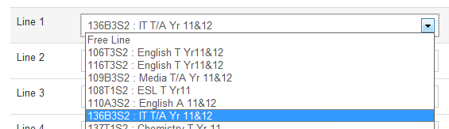

When you select your English classes, choose the class/unit you most want to get into, you will then be prompted to select a second choice (in case you don’t get your first choice).

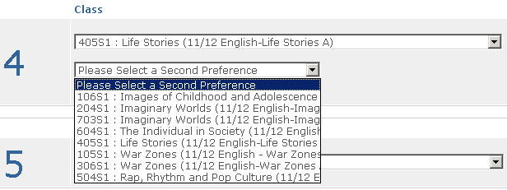

When you click on the list box, you will see all the other available English classes and what line they are on, select one.

You can also select Term or Half Point units, for example Outdoor Ed. or registered units. When you select the first half unit you will be prompted to select the second half unit.

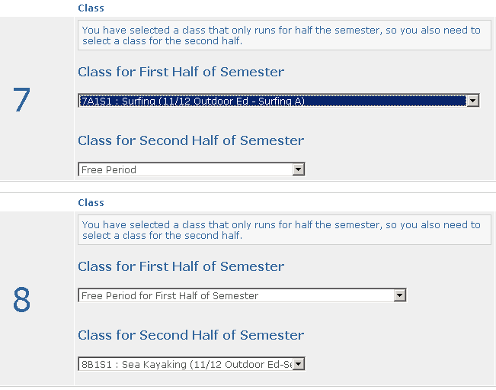

Year 11 MUST select a minimum of 5 classes. Year 12 MUST select a minimum of 5 classes

(Exceptions: ASBA students and a couple of other small groups who will be permitted to select less classes given their existing commitment.

Now it is time to set your preferences from the buttons on the right of screen.

- Set your first preference as the class you most wish to get eg a particular level of maths, on a particular line or a course you must continue.

- If you don’t mind which line you do it on you could make that a lower preference (say 4 or 5).

- You can also select free lines as a 1st (or 2nd etc preference), if you work on Monday afternoons and need line 3 off you could select “Free Period” on line 3 as your first preference.

When you have assigned a preference from 1- 10 (You can only use each number once!) for all lines you are finished. Hit the submit button to save your choices. Then logout to finish.

Students will not be allocated to classes until the website has closed. There is no advantage in rushing your selections. Take your time and choose carefully.

You can reselect your classes as many times as you wish until the website closes.

Students who have not submitted their selections when the website closes will have their subjects chosen for them.

